* VD: Redux Core + React Redux + Redux Toolkit

|  |  |  |
| --- | --- | --- |
| *Structure* | *Store* |  |

|  |  |
| --- | --- |
|  |  |

*Slide*

|  |  |
| --- | --- |
|  |  |

*Selector*

|  |  |
| --- | --- |
|  |  |

*Component*

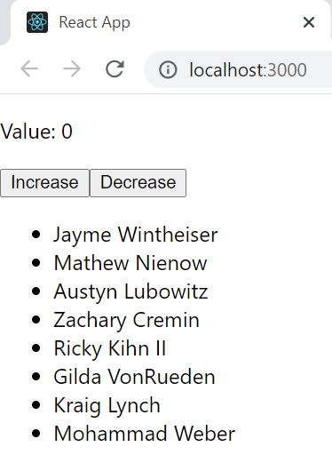

* **Reference**